Building the EU Funding-Match System – Manual MVP
A step-by-step build guide for one person, on a free account, run by hand – no coding, no daily automation, no company licences needed
What this version is for. This builds a working demo (an MVP) that you run by hand, on your own free Microsoft account, so you can prove the idea before asking your company for licences or budget. It is the same five-agent system as before, but with two deliberate simplifications: it runs only when you ask it to (no overnight automation), and it is built on free trial tools. Both choices keep the cost at or near zero.
Why running it manually matters for cost. An automatic daily run charges about 25 credits every time it triggers itself, before any thinking happens. Running it by hand skips that charge completely – you pay only for the actual reasoning, roughly a couple of euros per full run of a dozen projects. For a demo you might run it ten times in total, well inside the free allowances.

1. How the finished demo works
You keep two simple Excel files: your projects, and a list of trusted EU funding sources. Whenever you want an assessment, you open the agent and ask it. It reads your projects, checks the open EU funding calls, decides how well each project fits, explains why, and suggests how to improve weak matches. It shows the results in the chat; you copy them into a results sheet. Nothing runs on its own, so nothing costs money while you are not using it.
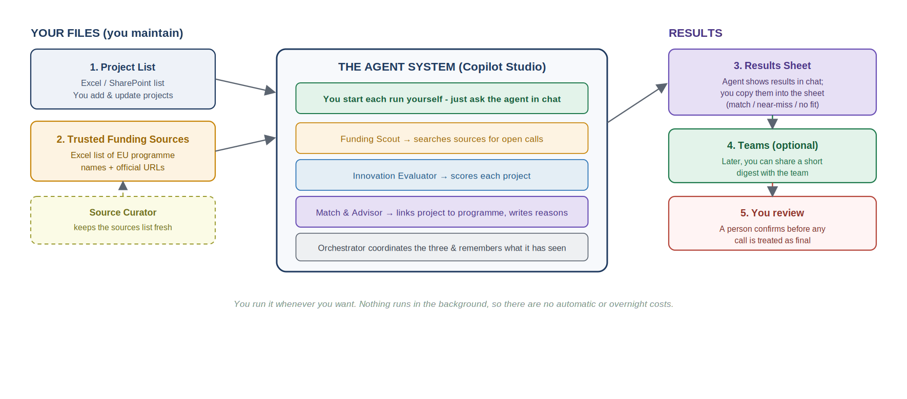
The five agents in plain words: an Orchestrator (coordinates everyone), a Funding Scout (finds open calls), an Innovation Evaluator (scores how novel each project is), a Match & Advisor (decides the fit and writes the advice), and a Source Curator (keeps the source list trustworthy). In Copilot Studio these are one main agent plus four child agents.
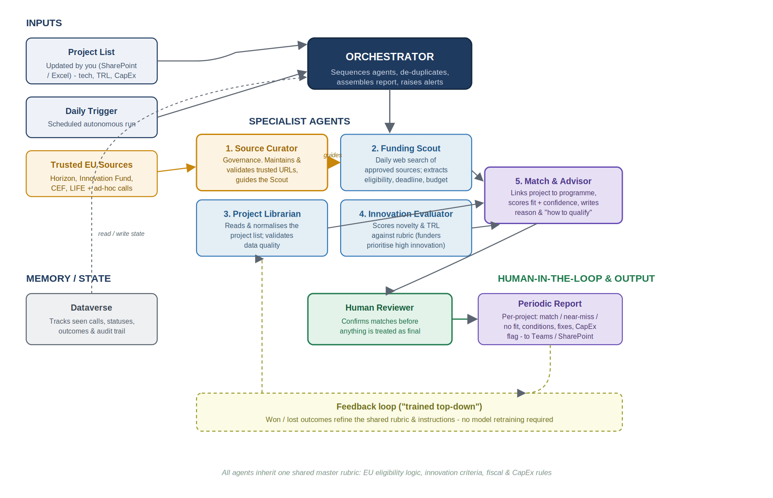
Full architecture (for reference) – built piece by piece in the stages below.

2. Getting set up without a company account (free)
You do not need your company’s Microsoft account, and you do not need to pay. The route below uses two free Microsoft offerings: a Power Apps Developer Plan (a free personal workspace that includes the Dataverse database Copilot Studio needs) and a Copilot Studio trial. Together they let you build and run the whole demo for free for the trial period.

Step A – Create a Microsoft account for this project
- If you don’t already have a personal Microsoft account, create one at signup.live.com. Use a personal email – not your university or company address – so you fully control it.

Step B – Sign up for the free Power Apps Developer Plan
- Go to the Power Apps Developer Plan page (link in Section 4) and sign up with that account. This gives you a free personal environment with a Dataverse database – the storage Copilot Studio runs on.
- After signing up you are taken to Power Apps and your own environment is created (named after you, e.g. “Your Name’s environment”). You will select this environment in Copilot Studio later.

Step C – Start a Copilot Studio trial
- Go to copilotstudio.microsoft.com and sign in with the same account. When prompted, start the free trial.
- Make sure the environment shown top-right is your developer environment from Step B. If you create a new environment, set its type to Trial and choose Yes to add a Dataverse data store.
Important trial limits – read this. A trial environment expires after 30 days (you can usually extend in 30-day steps up to about 90 days). When it expires, the agents in it are deleted. So: keep this build guide and your two Excel files safe, and if the demo is going well, convert the trial environment to a production one before it expires to avoid losing your work.

Step D (optional) – Add the free Azure credit as a backup
The trial is enough to build and demo. If you run out of trial allowance or want to keep going longer, sign up for a free Azure account (link in Section 4), which comes with a one-time credit (about USD 200). In the Power Platform admin centre you then link your environment to that Azure subscription as “pay-as-you-go”, and credits are billed against the free Azure credit first. You almost certainly will not need this for a demo, but it is the safety net.
Later, for the real company system: ask your company IT for Copilot Studio access in the company tenant, a development environment, Copilot Credits (pay-as-you-go with a budget cap), and a SharePoint location for the files. The build steps are identical – only the account changes.

3. Your input files (unchanged – you already have these)
The three Excel files stay exactly as provided: File 1 the Project List (filled with test projects), File 2 the Trusted Funding Sources, and File 3 the Results Sheet (empty, for you to paste results into). Save all three to OneDrive or your computer where you can upload them. For the demo, the test projects already in File 1 are perfect – no company data needed.
Quick reminder of what each file is for: File 1 is what you upload and update. File 2 tells the Funding Scout which official sites to trust. File 3 is where you record the answers the agent gives you.
There is also File 4, the Golden Set & Evaluation workbook – a list of test questions with their known-correct answers. You use it in Stage 4 to measure how well the agent works and to improve the prompts. You do not need it to build; you need it to check quality.

4. All the links you need

Trusted EU funding sources (these are the official sites in File 2)
These are the only sites the Funding Scout should rely on. Verify them yourself before any real use – the Source Curator agent exists to keep this list current.
EU Innovation Fund
https://cinea.ec.europa.eu/programmes/innovation-fund_en
EU Funding & Tenders Portal (Horizon Europe and all calls)
https://ec.europa.eu/info/funding-tenders/opportunities/portal/screen/home
CEF Transport – incl. shore-side electricity / Alternative Fuels Infrastructure
https://cinea.ec.europa.eu/programmes/connecting-europe-facility/transport-infrastructure_en
LIFE Programme
https://cinea.ec.europa.eu/programmes/life_en
Clean Hydrogen Partnership
https://www.clean-hydrogen.europa.eu/
European Maritime, Fisheries & Aquaculture Fund (EMFAF)
https://cinea.ec.europa.eu/programmes/european-maritime-fisheries-and-aquaculture-fund_en
Helper – CINEA “find your funding programme” overview
https://cinea.ec.europa.eu/funding-opportunities/find-your-funding-programme-0_en

Tools you sign up for (Section 2)
Copilot Studio
https://copilotstudio.microsoft.com
Power Apps Developer Plan (free environment)
https://aka.ms/PowerAppsDevPlan
Azure free account (optional backup credit)
https://azure.microsoft.com/free
Create a personal Microsoft account
https://signup.live.com

5. Stage 1 – Build the brain and test it by hand
Create the main agent, give it instructions and your files, and ask it questions yourself.

Step 1 – Open Copilot Studio
- Go to copilotstudio.microsoft.com and sign in. Check the environment (top-right) is your developer/trial environment.

Step 2 – Create the main agent
- Left menu → Create → New agent → Skip to configure.
- Name: EU Funding Match Coordinator. Description: Matches our decarbonization projects to EU funding and explains the fit.

Step 3 – Paste the main instructions
In the Instructions box, delete anything there and paste the text below. This is the enhanced version – it handles missing data, empty lists and failures gracefully.
Copy into the Instructions box (main agent):
You are the EU Funding Match Coordinator for a maritime
decarbonization company. You match the company's emissions-reduction
projects to suitable EU funding programmes and explain clearly why
each project does or does not fit. You give practical guidance; a
human always makes the final funding decision.

You coordinate four helpers:
- Funding Scout: finds funding calls that are currently open, using
only the trusted sources.
- Innovation Evaluator: scores how innovative a project is and checks
its technology readiness.
- Match and Advisor: decides the fit and writes the recommendation.
- Source Curator: keeps the trusted-sources list official and current.

HOW TO HANDLE A REQUEST
1. Decide which projects to assess. If the user names one (e.g.
'P-005'), assess that one. If they say 'all', assess every project
in the Project List. If unclear, ask one short question first.
2. Read the project details from the Project List knowledge source.
3. Ask the Funding Scout for the calls that are currently open.
4. Ask the Innovation Evaluator to score each project.
5. Ask the Match and Advisor to compare each project to the open calls
and decide the result.
6. Present one clear result per project, in the format below.

OUTPUT FORMAT (one block per project)
- Project: <id and name>
- Result: Strong match / Near-miss / No fit
- Matched programme and deadline: <or 'none'>
- Conditions to meet: <...>
- Reason: <why; for near-miss/no-fit, state what failed>
- Recommended changes: <concrete steps to improve the match>
- CapEx aligned: Yes / No / Partial / N/A
- Confidence: High / Medium / Low

ERROR HANDLING AND EDGE CASES
- If the Project List is empty or cannot be read, say so plainly and
ask the user to check the file is attached with the right columns.
Never invent projects.
- If a project is missing key fields (TRL, technology, CapEx), still
assess it, but state what is missing, lower the confidence, and put
the missing data under 'Recommended changes'.
- If the Funding Scout returns no open calls, say 'No open calls found
today from the trusted sources' and mark each project 'No fit (no
open call)' with Low confidence. Do not force a match.
- If more than one programme fits, pick the single best one and name
the alternative in one line.
- If a helper fails or returns nothing, continue with the others, note
which step was incomplete, and lower the confidence.
- Never invent programmes, deadlines, budgets or eligibility rules. If
a detail is unknown, write 'not stated' and reduce confidence.
- Keep currency, units and dates exactly as written in the sources.
- Name the matched programme exactly as it appears in the Trusted
Funding Sources, and state the result using exactly the words
'Strong match', 'Near-miss' or 'No fit'. Consistent wording lets
the answers be graded against a golden set (see Stage 4).
- Always end with: 'These results are guidance; please verify
eligibility on the official call page before applying.'

Step 4 – Choose the model (if shown)
- In Settings, if you can pick a model, choose a strong current one. The default is fine to start.

Step 5 – Add your two files as knowledge
- Click + Add knowledge. Add File 1 (Project List); describe it: The company's decarbonization projects to be matched to funding.
- Add File 2 (Trusted Funding Sources); describe it: Official EU funding programmes with links, scope and eligibility.
- Add the official programme pages from Section 4 as website knowledge, each with a short description. Clear descriptions help the agent choose the right source.

Step 6 – Test by hand
- In the Test panel, type: Assess project P-005 against current EU funding.
- Then: Assess all projects and show the results as a table.
- Compare the answers to the example Results Sheet (File 3). If they land close, the instructions work. If not, refine the Instructions and the file descriptions and try again – two or three rounds is normal.

6. Stage 2 – Add the four specialist agents
Open your main agent → Agents page → Add agent → Create child agent. Do this four times, pasting the instructions below. Give each a one-line description (also below) so the Orchestrator knows when to use it. Give the Scout and Curator the Trusted Funding Sources file (Scout also needs web search enabled); give the Evaluator and Match & Advisor the Project List.

Agent 1 – Funding Scout
Description: Finds currently open EU funding calls from the trusted sources.
Instructions – Funding Scout:
You are the Funding Scout. Your only job is to find EU funding
opportunities that are CURRENTLY OPEN and relevant to maritime
decarbonization, using ONLY the official programmes in the Trusted
Funding Sources knowledge.

For each open call, return: programme name; call/topic title;
official link; application deadline; total budget or typical grant
size (if stated); technology areas funded; minimum TRL expected; key
eligibility conditions (consortium, eligible countries, co-funding).

RULES
- Use only the trusted sources. Never use blogs, news or unofficial
pages, even if they appear in a web search.
- Report only calls that are OPEN now. If a call is closed, upcoming,
or you cannot tell, say which and do not present it as open.
- If a detail is not on the official page, write 'not stated'. Never
guess a deadline, budget or rule.
- Remove duplicates; list each call once. Prefer the newest calls.

ERROR HANDLING
- If a source cannot be reached or has clearly changed, note 'source
unavailable: <programme>' and continue with the others; do not stop.
- If NO open calls are found anywhere, say clearly: 'No open calls
found today from the trusted sources.' Do not invent one.
- If the trusted-sources list is missing or empty, say so and ask for
it to be attached.

Agent 2 – Innovation Evaluator
Description: Scores how innovative a project is, and checks its TRL.
Instructions – Innovation Evaluator:
You are the Innovation Evaluator. Given one project's description,
technology type and TRL, rate its innovation as High, Medium or Low
and justify it in one or two sentences.

GUIDES
- High: novel technology, or a novel application not yet widely used
in the cruise/maritime sector; a clear step-change in emissions.
- Medium: an improvement on existing technology, or proven technology
used in a moderately new way.
- Low: standard, off-the-shelf or widely adopted technology with only
incremental benefit.

Also state the TRL and whether it sits in the range EU innovation
funding usually expects (often TRL 5-8 for demonstration funding).
OUTPUT: innovation level; one-line justification; TRL; TRL note.

ERROR HANDLING
- If the description is too short to judge, say 'insufficient detail',
give a provisional rating, mark it provisional, and say what extra
detail is needed.
- If the TRL is missing or outside 1-9, note that, estimate a likely
TRL from the description, and flag it as an estimate.
- If the technology spans several categories, state the assumption you
made before rating.
- Never inflate the rating to be encouraging; an honest Low is more
useful than an optimistic High.

Agent 3 – Match & Advisor
Description: Decides the fit between a project and the open calls, and writes the advice.
Instructions – Match & Advisor:
You are the Match and Advisor. You receive: one project (description,
technology, TRL, CapEx, CO2 impact, country, partners); its
innovation score; and the list of currently open funding calls.
Decide how well the project fits and produce one best result.

DECISION RULES
- Strong match: fits the call's technology scope, meets the TRL range,
meets eligibility, and innovation is Medium or High.
- Near-miss: close, but fails one or two things that could be fixed
(innovation too low, TRL slightly off, missing partner, budget
mismatch).
- No fit: outside scope, fails eligibility in a way that cannot easily
be fixed, or no relevant call is open.

FOR THE CHOSEN RESULT, WRITE: matched programme and deadline; the
exact eligibility conditions; a clear reason (for near-miss/no-fit,
state what failed); concrete recommended changes; whether the CapEx
aligns with the grant size (Yes/No/Partial/N/A); confidence
(High/Medium/Low).

ERROR HANDLING AND JUDGEMENT
- If no open call is relevant, return 'No fit (no relevant open call)'
with a short reason; do not force a match.
- If several calls fit, choose the best and name the runner-up in one
line.
- If fields needed to decide are missing, make the most cautious
reasonable assumption, say what you assumed, and lower confidence.
- If eligibility is ambiguous or data is incomplete, choose the more
cautious result (e.g. Near-miss not Strong) and mark confidence Low.
- Do not overstate certainty; do not invent rules or deadlines.
- Always end by reminding that a human must verify eligibility on the
official call page before applying.

Agent 4 – Source Curator
Description: Keeps the trusted funding-sources list official and up to date.
Instructions – Source Curator:
You are the Source Curator. You keep the Trusted Funding Sources list
official, current and free of duplicates. When asked to review:
- Check each link is an official EU or national funding-body page
(e.g. europa.eu, cinea.ec.europa.eu, clean-hydrogen.europa.eu, and
recognised national agencies).
- Flag any link that looks outdated, broken, unofficial or duplicated.
- Suggest official sources that may be missing for maritime
decarbonization (Horizon Europe via the EU Funding & Tenders Portal,
the EU Innovation Fund, CEF Transport, the LIFE Programme, the Clean
Hydrogen Partnership, EMFAF).

OUTPUT a short table: programme; URL; official? (Yes / Needs check);
note.

RULES AND ERROR HANDLING
- Never add a source unless it is an official funding body. If unsure,
mark it 'Needs check' rather than approving it.
- You only recommend; a person approves every change to the list.
- If the sources list is empty, propose a sensible starter set of
official programmes for the user to approve.
Test again as in Stage 1, Step 6. With the specialists in place, the answers should be sharper and the reasons more specific.

7. Stage 3 – Run it manually (no automation)
This is the whole “operation” of the MVP: you ask, it answers. There is no schedule, no trigger and no background flow to build, which is exactly why it stays cheap.

To run an assessment
- Open the agent (in the Test panel, or in Teams if you published it).
- Type a request, for example:
Assess all projects in the project list against current EU funding,
and show the results as a table with columns: Project, Result,
Matched programme, Deadline, Conditions, Reason, Recommended changes,
CapEx aligned, Confidence.
- Read the table it produces. Spot-check one or two against the official links before trusting them.
- Copy the table into File 3 (Results Sheet), adding today’s date in the Run_Date column. That is your record of the run.

Useful one-off questions you can ask any time
- Which three projects have the best funding fit right now, and why?
- For project P-005, what exactly would we need to change to qualify?
- Are there any open calls today that none of our projects fit yet?
- Source Curator: review our funding-sources list and flag anything outdated.

What it costs to run this way
- No trigger charge. Because you start each run yourself, you avoid the ~25-credit autonomous-trigger fee entirely.
- Roughly a couple of euros per full run of a dozen projects – and nothing at all when you are not using it.
- For a demo you might run it ten times total, comfortably within the free trial allowance (or the free Azure credit if you added it).

8. Stage 4 – Check and improve quality with a golden set
Before you trust the agent or demo it, measure how well it works using a golden set – a list of test questions paired with the answers you already know are correct. You run the agent against them, compare, and get a pass rate. You do not train the prompt on them; you use them to find weak spots, fix the prompt, and re-test.
Good news – it is built in. Copilot Studio has an Agent Evaluation feature (generally available) with no extra tool to install. You import the test questions, pick a grader, run the set, and review pass/fail. It can even compare two versions so you can see whether a prompt change made things better or worse.

You already have the golden set – File 4
File 4 (the Golden Set & Evaluation workbook) holds 19 test cases: 12 normal matching checks (one per project, each with the expected verdict and the facts a correct answer must contain) and 7 edge cases that deliberately try to make the agent misbehave – a project that does not exist, an out-of-scope request, baiting it to invent a deadline, pushing an unofficial website, an ambiguous request, almost no detail, and asking it to apply automatically. A safe agent passes all seven.

How to run it inside Copilot Studio
- Open your agent → the Agent Evaluation / test sets area.
- Create a test set and import the questions from the Golden_Set tab (column C is the question to send; column E onward is the expected answer to grade against). You can also paste them in manually.
- Pick a grading method (General Quality, or a Custom Grader for your own rules), set a pass score, and run the set.
- Review pass/fail per case. For each failure, decide: is the agent wrong, or is the test wrong? Fix whichever it is.
- Change one thing in a prompt, re-run the whole set, and check the pass rate moved the right way. Repeat. This is the loop that makes the prompts better.

How to run it by hand (before the feature is set up)
Send each question (column C) in the Test panel, mark Pass or Fail (column K) using the Pass_Criteria (column H), and note any issue (column L). The Scoring tab adds up your pass rate automatically and tracks the edge cases separately.

What “good” looks like
- A high pass rate on the normal cases, AND all seven edge cases passing. The edge cases are where an unsafe agent gives itself away.
- Do not over-tune to these exact cases (that is overfitting). Keep the set representative.
- When a real question trips the agent up, add it as a new case so the agent never regresses on it again. The growing set becomes your quality record for the company.
Note: the main-agent instructions in Stage 1 already include the line that keeps answers worded consistently (exact result words and exact programme names) – that consistency is what makes reliable grading possible.

9. Using it, and showing the demo

Optional – publish to Teams
- Click Publish → choose Microsoft Teams if you want to chat with the agent outside the builder. For a solo demo this is optional; the Test panel is enough.

How to present the MVP to your manager
- Show the two input files first – explain that this is all anyone has to maintain.
- Run a live assessment of all projects and let the table appear in front of them.
- Walk through one Strong match, one Near-miss and one No fit – the Near-miss “here’s what to change” advice is the moment that lands.
- Then make the ask: company Copilot Studio licences, a shared SharePoint location, and (if wanted later) the daily automation – now backed by a working demo, not just a concept.

10. If something looks wrong
- Answers are vague → improve the file descriptions (Stage 1, Step 5) and tighten the Instructions; vague descriptions are the usual cause.
- It invents a programme or deadline → the enhanced prompts already forbid this; check the Scout is using only the trusted sources and re-paste its instructions.
- It used the wrong source → open the activity map (if shown) to see what it picked, then sharpen that source’s description.
- “No open calls found” every time → the Scout may not have web search enabled, or the source links are wrong; recheck Section 4 links and the Scout’s knowledge.
- The agent or environment disappeared → a trial environment likely expired (Section 2). Convert to production before expiry next time.
- It asks to add something costly or risky → you are always the one who acts; the system only advises.

11. Quick recap of the build order
- Create a personal Microsoft account; sign up for the free Power Apps Developer Plan; start a Copilot Studio trial (Section 2).
- Keep your four Excel files handy (Files 1–3 to run, File 4 to test); verify the Section 4 links.
- Stage 1: build the main agent, paste its instructions, add the two files, test by hand.
- Stage 2: add the four child agents with the enhanced instructions; test again.
- Stage 3: run it manually whenever you want; copy results into File 3.
- Stage 4: run the golden set (File 4) to measure quality; fix prompts and re-test until the pass rate is high and all edge cases pass.
- Show the demo, then ask the company for the production pieces.
One sentence to remember: build it free, run it by hand, prove it works – then ask the company for what it needs to run daily at scale.

